Project Design Phase-II

Data Flow Diagram & User Stories

|  |  |
| --- | --- |
| **Date** | **03 October 2022** |
| **Team ID** | **PNT2022TMID33581** |
| **Project Name** | **AI - powered Nutrition Analyzer for Fitness Enthusiasts** |
| **Maximum Marks** | **4 Marks** |

**Data Flow Diagrams:**

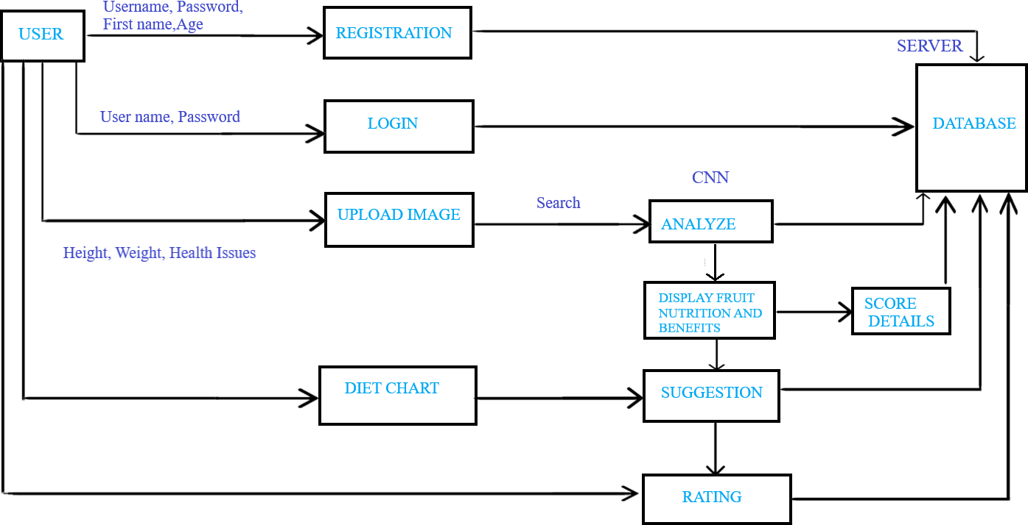

|  |  |  |  |  |  |  |
| --- | --- | --- | --- | --- | --- | --- |
| **User Type** | **Functional Requirement (Epic)** | **User Story Number** | **User Story / Task** | **Acceptance criteria** | **Priority** | **Release** |
| Customer | Registration | USN-1 | As a user, I can register for the application by entering my email, password, and confirming my password. | I can access my account / dashboard | High | Sprint-1 |
|  |  | USN-2 | As a user, I will receive confirmation email once I have registered for the application | I can receive confirmation email & click confirm | High | Sprint-2 |
|  |  | USN-3 | As a user, I can register for the application through Google. | I can register & access the dashboard with Google Login. | Low | Sprint-3 |
|  | Login | USN-4 | As a user, I can log into the application by entering  username & password | I can login the application by entering  password | High | Sprint-1 |
|  | Dashboard | USN-5 | As a user, I can access any of the options available there. | I can access my resource | High | Sprint-4 |
|  | Rating | USN-6 | As a user, Rating the services | Maintain and Improve the performance | High | Sprint-4 |
| Customer Care Executive | Feature Extraction | USN-1 | As a user, I can input any of the image of fruit in the upload field and will get the results of the image. | As a user I will know the nutrients in the fruit. | High | Sprint-1 |
| Diet Chart | Customer record | USN-1 | Based on the customer height , weight etc… suggest the nutrition fruit for the customer | Improve the customer health results | High | Sprint-4 |
| Administrator | Prediction | USN-1 | Here the model will predict the image using deep learning algorithms  Such as CNN. | In this I can have correct prediction on the particular algorithms. | High | Sprint-2 |
|  | Classifier | USN-2 | Here I will send all the model outputs to classifier in order to produce final results. | In this I will find the correct answers for producing the results. | Medium | Sprint-3 |